2027 ISB Network Reunion
Seas the Day
Thursday, July 15 to Monday, July 19, 2027

All Aboard the Carnival Glory
Our new cruise dates are July 16, 2027 – July 19, 2027
Click the link for detailed information on our ship, Carnival Glory
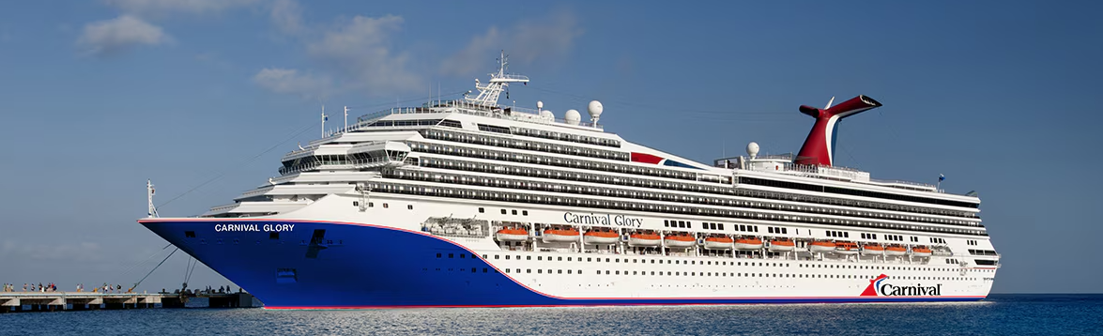

Our Reunion/Cruising Itinerary
(the actual sailing ship and itinerary are subject to change)

Welcome Reception July 15 One-night hotel stay and welcome
Reception at The Doubletree by Hilton, Orlando Airport
Depart Port Canaveral, Florida July 16 3:30 PM
Celebration Key, Bahamas July 17 10:00 AM – 5:00 PM
Fun Day at Sea July 18 All day cruising
Return to Port Canaveral and depart ship July 19 8:00 – 10:30 AM

Thursday, July 15, 2027

Please book your flights to arrive at Orlando Airport (MCO). Take the hotel shuttle to the group hotel (DoubleTree by Hilton, Orlando Airport), check-in, and then enjoy a welcome reception at 6:00 PM with your fellow ISB alumni.

Friday, July 16, 2027
Please bring your luggage to the lobby by 10:00 AM for tagging before departure. Chartered buses will depart from the hotel beginning at 11:00 AM for Cape Canaveral.
Departure ~ 3:30 PM Carnival Glory Cruise
- Activities: Afternoon boarding. Enjoy the ISB Cocktail sail-away party, followed by the first evening of entertainment and dining included on the cruise.

Saturday, July 17, 2027
Celebration Key, 10:00 AM – 5:00 PM: Enjoy a fun filled day relaxing, swimming, shopping, entertainment, and dining.
- Paradise Plaza – Central hub with guest services area, the Suncastle and slides, and tram transfer points
- Starfish Lagoon – Family-focused pool and beach area with casual dining and water activities
- Calypso Lagoon – A mix of lively areas with swim up bars, DJ, and sports
- Pearl Cove Beach Club – Premium 18+ beach club with pool, beach, and restaurant (paid access only)
- Lokono Cove – Cultural shopping village and shore excursion exit area

Return to the ship by 5:00 PM for an evening of fun activities of your choice included in the cruise. The ship departs Celebration Key at 6:00 PM.

Sunday, July 18, 2027
Fun Day at Sea
- Relax by the pool, enjoy our Special ISB activities, shows, spa, casino, and dining.

Monday, July 19, 2027

Return to Port Canaveral
- Arrival ~ 8:00 AM
- Disembark ~ 8:00 – 10:30 AM
- If you are returning to the Orlando Airport on Monday, board assigned buses to catch your flight home.

If you wish to “hang out” longer and take advantage of being in Central Florida, consider the many sightseeing options available to you: Theme Parks (Disney, Sea World, and Universal), Kennedy Space Center, Cocoa Beach, Kayak, Brevard Zoo, Winter Park Art Museums and boat ride, Orange County History Center and Science Center, or visit historical St. Augustine.

Our Reunion Prices: The DoubleTree by Hilton, Orlando Airport Hotel

The DoubleTree by Hilton, Orlando Airport room rate is $159.00 ++ per night. The room block rate is available from Monday, July 13, to Tuesday July 20, 2027. The Bon Voyage reception cost is $70.00 per person and includes heavy hors d’oeuvres.

Our Reunion Prices: The Staterooms

The following are our lowest contracted per person stateroom rates for 2027 based on two people per cabin with a maximum of two people per cabin. If you are rooming solo (not sharing a cabin), the cost is the FULL amount of the cabin (double the per-person rate). These are the PER PERSON prices for 2027 based on 2 sharing a cabin (2 guests max per cabin).

Stateroom Options
Interior Category 4E: $584.00 P/P Ocean View Category 6B: $644.00 P/P

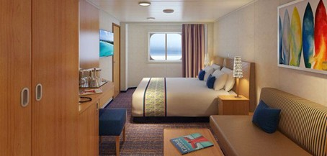
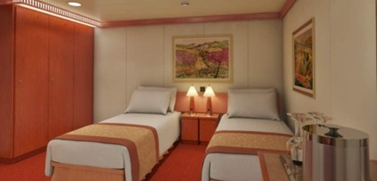

Balcony Stateroom Category 8A: $767.00 P/P
Balcony staterooms were designed for maximum sea breeze and the most stunning views.

All Staterooms Include:
- Dedicated stateroom attendant
- Soft, cozy linens
- Plenty of closet and drawer space
- In-room safe for valuables
- Television
- Stateroom climate control
For families looking to save costs, there are also many cabins suited to accommodate four people, using cabins outfitted with upper and lower berths.
Ocean Suites are not included in our cabin block, but if you are interested in reserving one, please email Lloyd Coleman or call him at 562-706-7186, Monday-Saturday, 10:00 AM – 4:30 PM (Arizona time) for pricing and availability.
Ocean Suite Amenities:
- Priority check-in and boarding
- Immediate access to your suite after boarding
- Priority Main Dining Room time assignment
- Priority dinner reservations at most specialty dining spots
- Priority debarkation at homeport, and ports of call requiring a water shuttle or with arrival times later than 9:30 AM
- Complimentary wash & fold laundry service (1 bag per cruise)
- Two large bottles of water
- Pillow-top mattress
- Curated in-stateroom bath products
- Bathrobes

The Cruise Booking

If you took advantage of the “EARLY BIRD” deposit opportunity, your space is already reserved, and there is nothing you need to do at this time.

- Your non-refundable deposit has been transferred to Carnival.
- When you are ready to move forward to confirm a cabin assignment, please reach out to
Lloyd Coleman who will work directly with Carnival to make the booking for you. The cost is $100.00 per person. Once the booking is activated, you will be able to access it online to set up your insurance, shore excursions, gratuity packages, and drink package purchases.
- Final payments are due 90 days before sailing.
- Please keep in mind that the sooner you reserve your cabin with Lloyd, the better opportunity you will have to secure your preferred cabin type.

If you have not made a reservation but want to do so now, the deposit requirement is $125.00 per person.

For reunion-specific questions, contact Teresa Martin, Director of Reunions or call her at
602-509-6071, Monday – Saturday, 9:00 AM – 6:00 PM (Arizona time)

For cruise/Carnival questions, contact Lloyd Coleman at SeasTheDayIn2027@gmail.com or call him at 562-706-7186, Monday-Saturday, 10:00 AM – 4:30 PM (Arizona time)

